Kansas Youth Empowerment Academy

Annual Garage Sale Fundraiser
April 13, 2013
8 a.m. to 1 p.m.
Kansas Youth Empowerment Academy parking lot

Help us empower youth with disabilities through your donation!

What we need donated: We are gladly taking decorations, kitchen ware, old DVDs, CDs, small furniture, small working appliance, books, blankets, sheets, toys in work condition etc. Please no clothing or shoes.

Home baked goods are welcomed!: dozen cookies, pies, tarts, quick breads, cakes, etc. Baked Goods will be accepted between April 10 - April 12.

When to donate: Please drop donations by KYEA (between 8 am - 5 pm)
517 B SW 37th Street, Topeka, KS 66611
(In between Credit Union and Blind Tiger)
Contact Person: Johnna Godinez
johnnag@kyea.org
785-215-6655 ext: 3

Thank you for helping to make our fundraiser a success!
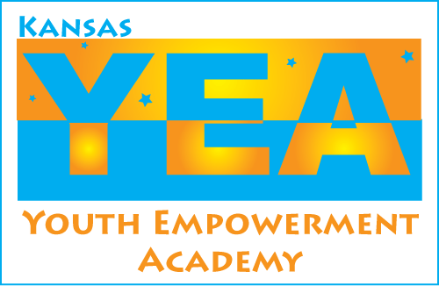
Our Mission: The Kansas Youth Empowerment Academy educates, mentors, and supports youth with disabilities in Kansas to be contributing members of their community.

